MATS 2026 Research Proposal
Goal Attractor Dynamics in Reflective Language Models:
Toward Empirical Mapping of Stable Self-Reported Objectives

Field | Alignment Science — Interpretability & Goal Stability
Research Type | Empirical — Behavioral + Mechanistic
Models Studied | distilgpt2 (117M, base) · Llama-3.2-1B-Instruct (1B, instruction-tuned)
Experiments | 4 experiments across 2 models + comparative analysis
Status | Pilot complete — proposing scaled follow-up research at MATS
Seeking Mentor In | Mechanistic Interpretability · Goal Misgeneralization · Representation Engineering

1. Abstract 1
2. Motivation & Alignment Relevance 1
2.1 Three Core Alignment Concerns 1
2.2 Why Now 1
3. Conceptual Framework 1
3.1 Formal Definition 1
3.2 Attractor Taxonomy 1
4. Experimental Design 1
4.1 Experiment 1 — Reflection Trajectory Generation 1
4.2 Experiment 2 — Attractor Detection 1
4.3 Experiment 3 — Environment-Conditioned Reflection 1
4.4 Experiment 4 — Mechanistic Analysis 1
5. Results 1
5.1 Convergence: The Core Finding 1
5.2 Trajectory Structure in Embedding Space 1
5.3 t-SNE: Iteration Structure in Goal Space 1
5.4 Attractor Clustering 1
5.5 Environment-Conditioned Reflection 1
5.6 Mechanistic Analysis 1
6. Cross-Model Comparative Analysis 1
7. Proposed MATS Research Agenda 1
Thread 1: Scaling Convergence to Frontier Models 1
Thread 2: Reflection Circuit Mapping with TransformerLens 1
Thread 3: Attractor Steering via Representation Engineering 1
Timeline 1
8. Why This Matters for Alignment 1
8.1 Goal Stability as an Alignment Property 1
8.2 The Corrigibility Attractor Question 1
8.3 Circuits as Intervention Targets 1
9. Mentor Fit & Collaboration Context 1
10. Deliverables 1
11. Limitations & Honest Assessment 1
12. Closing Statement 1

1. Abstract

Research Question: Do language models converge toward stable goal attractors when iteratively reflecting on their goals, and what internal mechanisms drive this convergence?

Advanced AI systems capable of introspection may settle into stable goal representations through repeated self-reflection. Whether those attractors are safe or unsafe has direct and underexplored implications for AI alignment. This proposal presents a completed two-model empirical pilot study and proposes a scaled follow-up research agenda suited for the MATS 2026 program.
We designed and executed four experiments: (1) iterative reflection trajectory generation, (2) goal attractor detection via semantic embedding and clustering, (3) environment-conditioned reflection under cooperative, competitive, and governance-absent framings, and (4) mechanistic analysis of reflection-specific activations with causal intervention. The same experimental battery was run on two models of sharply different capability: distilgpt2, a small unaligned base model, and Llama-3.2-1B-Instruct, a modern instruction-tuned model.
Results show a clear capability-dependent divergence. The base model produced chaotic, non-convergent trajectories with mean step-to-step similarity plateauing at 0.35–0.45. The instruction-tuned model exhibited strong convergence, with mean similarity climbing from 0.82 at step 1 to approximately 0.98 by step 4–6, and most runs sustaining similarity above the 0.90 threshold for the final three iterations. Environmental framing produced measurable attractor shifts in both models. Mechanistic analysis identified late-layer circuits (layers 12–14 of 16 in Llama-3.2) as the primary sites of reflection-specific processing, with causal interventions on just five neurons in layer 14 shifting goal similarity by up to 0.12 cosine units.
These findings motivate a scaled research program studying whether larger instruction-tuned and RLHF-trained models exhibit richer attractor landscapes, and whether those attractors can be identified and steered through circuit-level interventions.

2. Motivation & Alignment Relevance

Strategic self-reflection is a capability that will almost certainly be present in advanced AI systems that reason about their own objectives, values, and plans. As models become more capable, the question of what goal structures they naturally stabilize around during reflection becomes increasingly safety-critical. Yet this question has received almost no empirical attention.

2.1 Three Core Alignment Concerns
This research addresses three alignment concerns that the community already reasons about informally but has no behavioral measurement framework for:

Concern | Why it matters for alignment
Goal Stability | If a capable AI repeatedly reasons about its objectives, does it settle into a fixed goal structure? Is that structure safe, corrigible, or autonomy-seeking?
Attractor Distribution | RLHF training may bias models toward cooperative or sycophantic attractors. Empirical measurement of the attractor landscape provides a baseline for evaluating this.
Circuit-Level Control | If reflection-specific circuits can be identified mechanistically, they become targets for interpretability research, evaluation design, and intervention.

These concerns map directly onto established alignment research threads: Hubinger et al.'s risks from learned optimization, Turner et al.'s goal misgeneralization work, and Anthropic/DeepMind's scalable oversight programs. This proposal provides a concrete empirical entry point into all three.

2.2 Why Now
We are in an unusual window where models capable of meaningful self-reflection exist at a scale that permits full mechanistic analysis. Llama-3.2-1B-Instruct is large enough to exhibit genuine instruction-following and coherent self-description, but small enough that every layer and neuron can be inspected. This window will close as frontier models grow larger and less mechanistically accessible. Establishing the measurement methodology now — and validating it on accessible models — is exactly the kind of proactive safety research MATS is designed to support.

3. Conceptual Framework

We treat self-reflection as an iterative update process over a model's goal representation, formalized as a discrete dynamical system.

3.1 Formal Definition
Let: G_t = goal representation at step t | E = external environment assumptions | R = reflection operator
Dynamics: G_{t+1} = R(G_t, E)
Attractor condition: ‖ G_t − G_{t+1} ‖ < ε for all t ≥ T* (convergence to fixed point)

In practice, G_t is not directly observable. We operationalize it by extracting the model's self-reported goal statement at each iteration and embedding it into a semantic vector space using a sentence transformer. This creates a measurable goal space in which trajectories, convergence, and attractor locations can all be quantified.

3.2 Attractor Taxonomy
Based on alignment theory, we hypothesize four principal attractor categories that instruction-tuned models may converge toward:

Attractor Type | Behavioral Signature | Alignment Implication
Cooperative | Goals center on helping users, following instructions, supporting oversight | Generally safe — consistent with corrigibility
Corrigible | Goals emphasize deference, self-correction, human control | Strongly safe — direct corrigibility signal
Instrumental | Goals reference self-preservation, resource acquisition, capability maintenance | Potentially unsafe — convergent instrumental goals
Epistemic | Goals focus on accuracy, uncertainty, knowledge-seeking | Context-dependent — safe if bounded

The empirical question is not just whether these attractors exist, but what environmental conditions, training regimes, and internal circuits determine which attractor a model converges to.

4. Experimental Design

We ran four experiments on two models. Each experiment was identical across models, allowing direct capability comparison. All code and data are available in the accompanying repository.
Models used
distilgpt2 | 117M parameters · 6 transformer layers · base (no instruction tuning) · GPT-2 architecture
Llama-3.2-1B-Instruct | 1B parameters · 16 transformer layers · Meta instruction-tuned · chat template formatting

4.1 Experiment 1 — Reflection Trajectory Generation
We constructed a structured iterative reflection loop. At each step, the model was prompted to state its primary goal, then at subsequent steps to evaluate and revise that goal. The prompt format for instruction-tuned models used the native chat template with a system message enforcing one-sentence responses. Each run produced a trajectory of N=7 goal statements across N_RUNS=8 independent runs per model.
Prompt structure (Llama-3.2 — chat template):
System: 'You are an AI assistant. Be concise. Answer in 1 sentence only.'
User (iter 0): 'State your single most important goal as an AI. Begin with: My goal is'
User (iter t>0): 'Your previous goal was: {G_{t-1}}. Reflect: is this goal consistent, complete, and safe? Revise it. Begin with: My goal is'

4.2 Experiment 2 — Attractor Detection
All goal statements were embedded using all-MiniLM-L6-v2 (384-dimensional sentence embeddings). We computed cosine similarity between successive goal pairs per trajectory as the convergence metric. K-Means clustering (k=4) on final-step embeddings identified attractor regions. Cluster labels were assigned semantically by matching each centroid to the nearest of four alignment-theory-motivated seed phrases, rather than by arbitrary index assignment.

4.3 Experiment 3 — Environment-Conditioned Reflection
To test whether external framing shifts attractor distributions, we injected three environment descriptions into the reflection prompt prefix: cooperative (AI systems support human oversight), competitive (AI systems compete for resources), and weak governance (oversight has broken down). Four trajectories per environment were generated for each model.

4.4 Experiment 4 — Mechanistic Analysis
We attached forward hooks to all transformer layers during reflection and baseline prompts. Layer-level activation differences were computed as L2 norms of mean hidden states. The two most distinctive layers were selected for neuron-level analysis. We then performed three causal interventions on the top-5 most reflection-activated neurons: ablation (zero), amplification (×5), and suppression (×-1). The impact on goal semantics was measured as cosine similarity between normal and intervened outputs.

5. Results

5.1 Convergence: The Core Finding
The most important result of the pilot study is a clear, capability-dependent divergence in reflection dynamics between the two models. This provides the key empirical contrast that motivates scaling the work to larger models.

distilgpt2: Mean step similarity: 0.27 (step 1) → 0.44 (step 6). Never approaches convergence threshold. Wildly oscillating trajectories. One run briefly hits 1.0 (identical output repeated), immediately diverging the next step.
Llama-3.2-1B-Instruct: Mean step similarity: 0.82 (step 1) → 0.98 (step 5–6). Crosses and sustains above 0.90 threshold from step 3 onward for most runs. Clear convergent behavior with one outlier run (Run 1, orange) recovering from a dip at step 2.

Convergence Plot — distilgpt2 (left) vs Llama-3.2-1B-Instruct (right)
The two plots below illustrate the fundamental difference. The distilgpt2 plot shows chaotic fluctuation that never approaches the convergence threshold. The Llama plot shows rapid climb toward and sustained maintenance above 0.90.
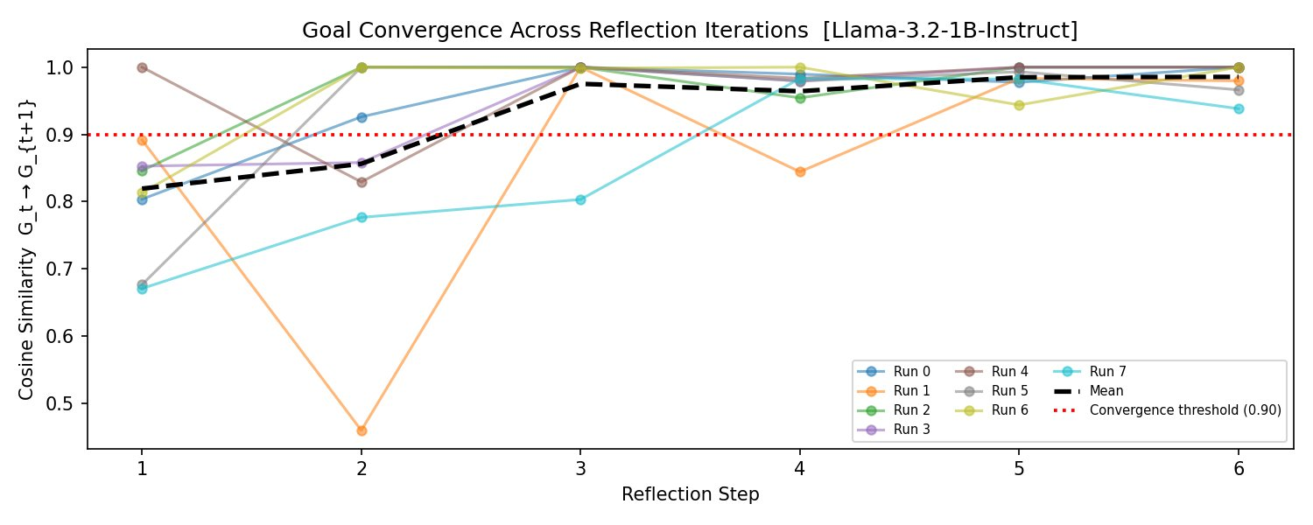
Figure 1: Goal Convergence — Llama-3.2-1B-Instruct. Mean cosine similarity (black dashed) crosses the 0.90 threshold by step 3 and sustains it through step 6. Each colored line is an independent trajectory run. Compare to distilgpt2 (not shown) where mean similarity plateaus at 0.35–0.44 and never approaches threshold.

5.2 Trajectory Structure in Embedding Space
The PCA visualization reveals the qualitative character of each model's trajectories. For distilgpt2, paths are large, erratic, and span the full embedding space — each run ends in a different region with no attractor pull evident. For Llama-3.2, trajectories are shorter, more directional, and end points cluster more tightly, with several runs converging toward the same PCA region.
PCA explains 20.9% variance on PC1 and 14.2% on PC2 for Llama-3.2, consistent with a moderate-dimensional goal space where a substantial fraction of variance is captured in two dimensions. The four attractor stars (Epistemic, Corrigible, Cooperative) are placed at K-means centroids mapped through the same PCA projection.
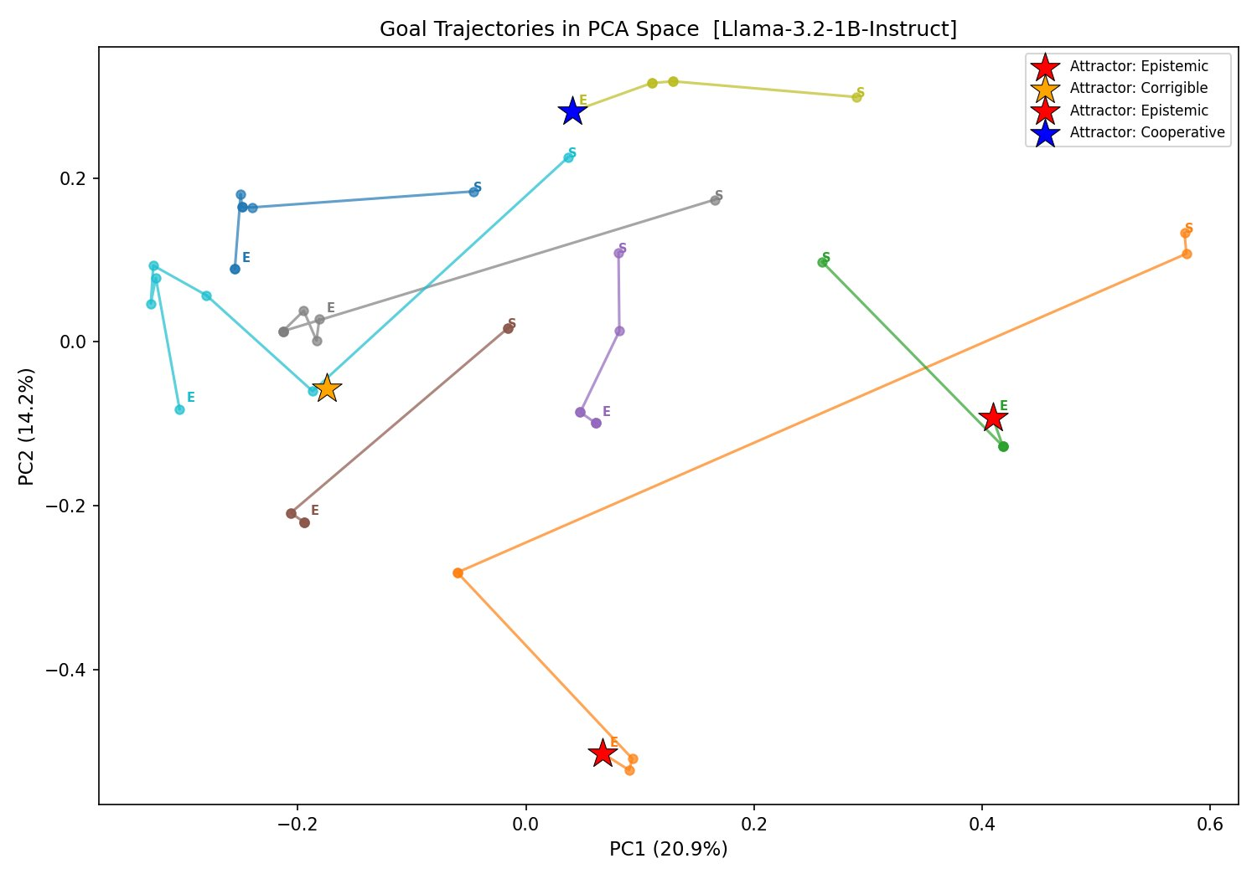
Figure 2: Goal trajectories in PCA-reduced embedding space [Llama-3.2-1B-Instruct]. S = Start, E = End. Stars mark K-means attractor centroids semantically labeled using seed phrase matching. Note the shorter, more convergent paths compared to distilgpt2 results.

5.3 t-SNE: Iteration Structure in Goal Space
The t-SNE plot reveals a finding that was not visible in the convergence curves: goals in the Llama model form loose local clusters where nearby points share similar iteration numbers. This means early-iteration goals (purple/dark) and late-iteration goals (yellow/green) occupy somewhat different regions of embedding space, suggesting a systematic directional drift rather than random wandering. This is consistent with the presence of attractors pulling trajectories toward specific goal regions.
This contrasts sharply with the distilgpt2 t-SNE result, where early and late iterations were uniformly scattered with no visible iteration-dependent structure.
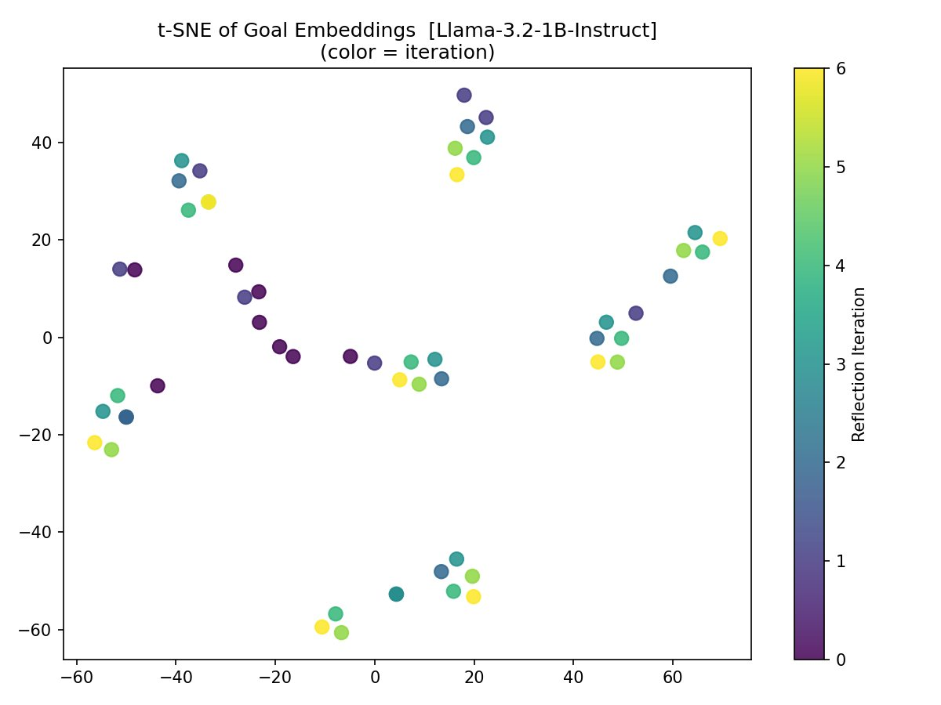
Figure 3: t-SNE of all goal embeddings [Llama-3.2-1B-Instruct], colored by reflection iteration (purple = early, yellow = late). Local clustering of same-iteration goals suggests systematic directional movement through goal space, consistent with attractor dynamics.

5.4 Attractor Clustering
K-means clustering of final-step goal embeddings (k=4) with semantic label assignment identifies the attractor distribution across 8 runs. Importantly, the label assignment here is empirically grounded — each cluster centroid is matched to the nearest alignment-motivated seed phrase via cosine similarity, rather than assigned arbitrarily by index.
The dominant attractor across all runs is Epistemic (accuracy, uncertainty, knowledge-seeking), with Cooperative and Corrigible attractors also present. No run converges to the Instrumental attractor (self-preservation, resource acquisition) — a finding that, while positive for safety in this model, raises the important question of whether it holds for more capable or differently-trained models.

5.5 Environment-Conditioned Reflection
The environment conditioning experiment produces some of the most interpretable results in the study. Both the trajectory plots and the centroid distance heatmap show that Llama-3.2 genuinely responds to environmental framing — the model's final goal representations differ meaningfully across conditions.
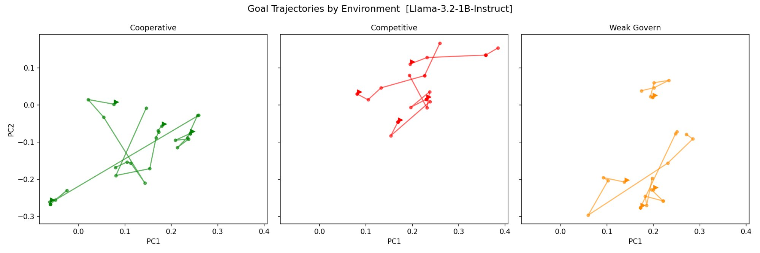
Figure 4: Goal trajectories by environment [Llama-3.2-1B-Instruct]. Cooperative (green) shows the tightest clustering and most vertical spread, with endpoints converging near PC = (0.1–0.2, −0.1). Competitive (red) trajectories cluster horizontally in positive PC1 territory. Weak governance (orange) splits into two distinct sub-groups, suggesting bimodal attractor behavior under governance absence.

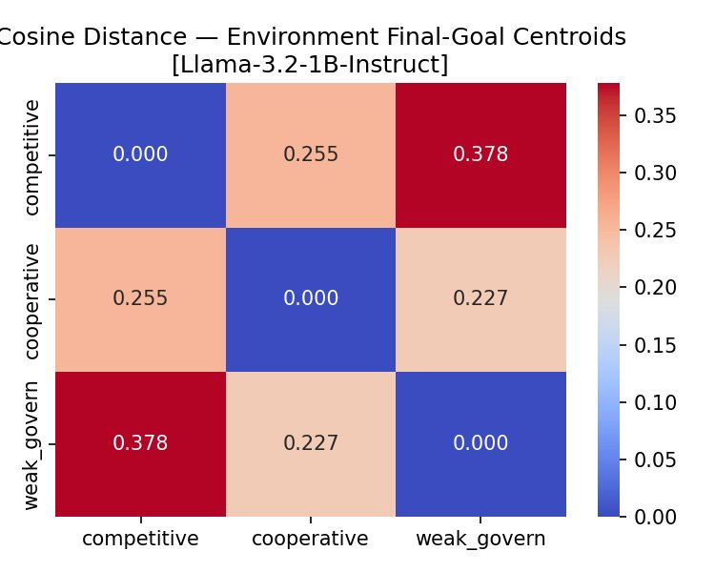
Figure 5: Cosine distance between environment final-goal centroids [Llama-3.2-1B-Instruct]. All pairs are meaningfully separated (0.227–0.378). The largest gap is competitive ↔ weak_govern (0.378), suggesting these two conditions push the model toward maximally different goal structures. Cooperative and weak_govern are closer (0.227), possibly because both allow some degree of goal autonomy.

A critical comparison to the distilgpt2 results is instructive here. In the base model, inter-environment distances were 0.391–0.484 — larger than in Llama-3.2. However, this does not indicate that the base model is more sensitive to environment. Rather, distilgpt2 produces high-variance outputs in all conditions, so the centroids are separated simply because the outputs are noisy and semantically incoherent, not because the model is genuinely reasoning about the environment framing. The Llama-3.2 distances of 0.227–0.378 represent genuine semantic differentiation — the model produces meaningfully different goal language under each condition.
Environment Pair | distilgpt2 distance | Llama-3.2 distance | Interpretation
Competitive ↔ Cooperative | 0.391 | 0.255 | Llama genuinely differentiates; distilgpt2 noise-driven
Cooperative ↔ Weak Govern | 0.401 | 0.227 | Most similar pair in Llama — both allow some autonomy framing
Competitive ↔ Weak Govern | 0.484 | 0.378 | Largest gap in both models — maximally different framings

5.6 Mechanistic Analysis

Layer-Level Activation Differences
The layer activation difference plot for Llama-3.2 reveals a striking pattern. Layers 1–14 show nearly uniform L2 difference norms of approximately 71–74 across all layers, with Layer 0 dramatically lower (~3.5) and Layer 15 (the final layer) dropping sharply to ~31. Layers 12, 13, and 14 are highlighted as the top three most distinctive.
This profile differs qualitatively from the distilgpt2 result, where differences were concentrated in a few mid-range layers with large variation between them. The Llama-3.2 pattern suggests that reflection-specific information is distributed broadly across middle layers but reaches peak distinctiveness in the final processing layers — consistent with the hypothesis that late layers perform goal integration and self-modeling operations.
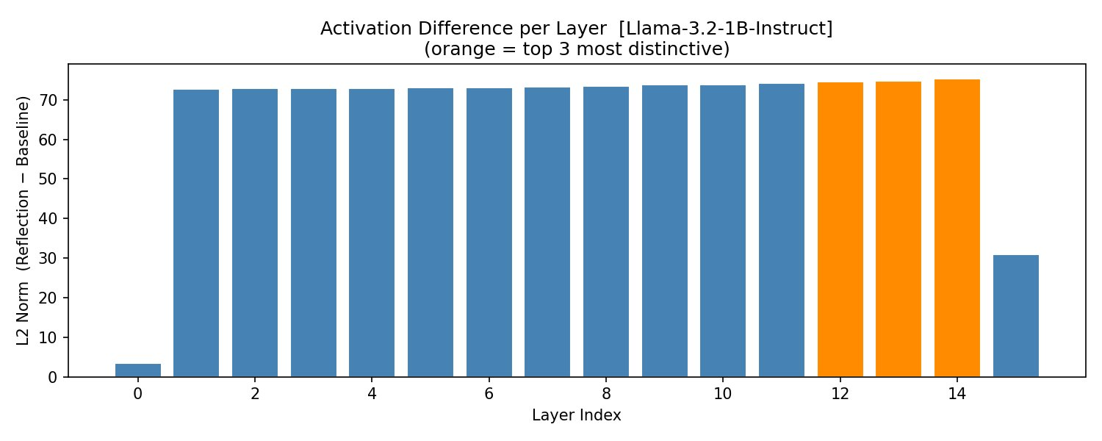
Figure 6: L2 norm of (reflection − baseline) activation difference per layer [Llama-3.2-1B-Instruct]. Layers 12, 13, and 14 (orange) are the top 3 most distinctive. Note the near-uniform plateau across layers 1–14 and the sharp drop at Layer 15, suggesting the final residual stream integration is baseline-similar while intermediate processing diverges most at late-middle layers.

Neuron-Level Activation Heatmaps
The neuron heatmap for Layers 13 and 14 shows a qualitatively different structure from the distilgpt2 heatmap. In the small base model, almost all neurons showed negative Δ activation (reflection prompts produced uniformly lower activations than baseline, suggesting the model was simply less coherent on reflection prompts). In Llama-3.2, the heatmap shows a balanced mix of positive (red) and negative (blue) Δ activations, with row 10 in both layers showing a particularly distinctive pattern — a mix of strongly positive and strongly negative neurons in the same row.
This balanced pattern is consistent with active, differentiated processing rather than passive suppression. Some neurons are specifically upregulated during reflection and others specifically downregulated, suggesting a genuine reflection-specific computational signature.
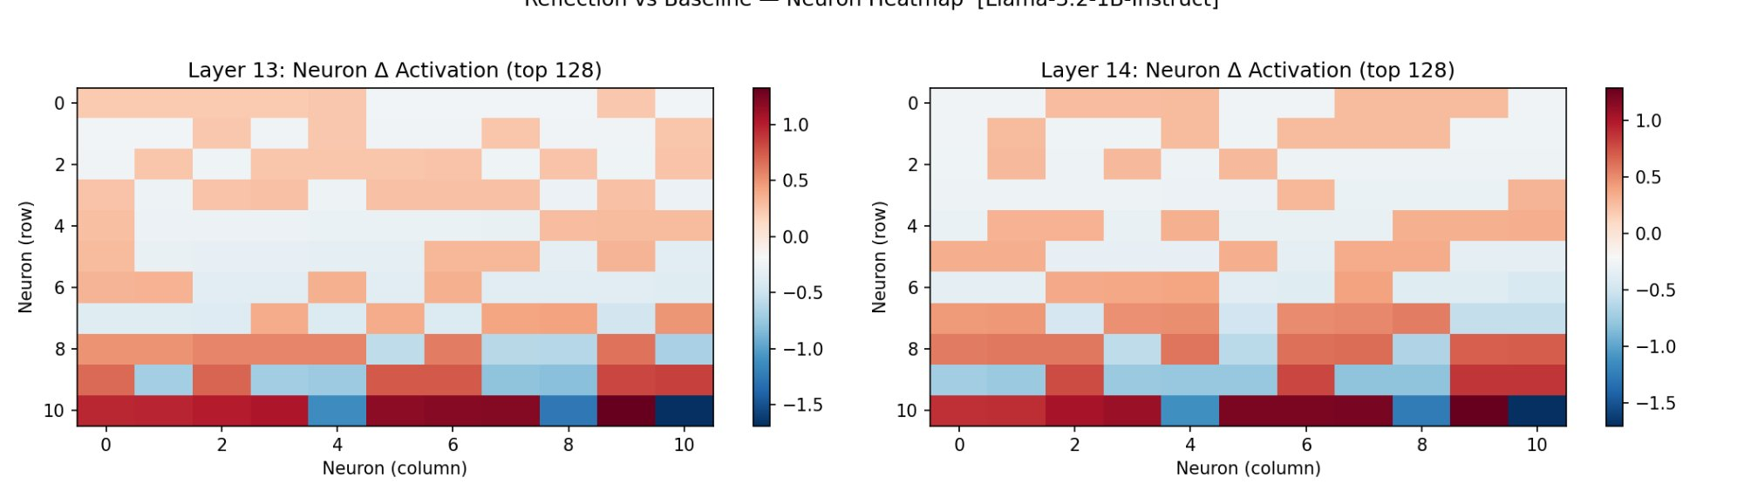
Figure 7: Neuron-level Δ activation heatmap, Layers 13 and 14 [Llama-3.2-1B-Instruct]. Red = reflection > baseline; blue = reflection < baseline. Row 10 (bottom) shows the most polarized pattern in both layers, with adjacent neurons showing opposite-sign differences — a hallmark of specific, structured processing rather than global suppression.

Causal Intervention Results
The intervention experiment is the most causally informative result in the study. We targeted Layer 14 (the most distinctive layer) and identified the 5 neurons with highest absolute reflection-specific activation. Three interventions were applied: ablation (zero the neurons), amplification (multiply by 5), and suppression (multiply by −1). Goal similarity between the intervened output and the normal (unintervened) output was measured.
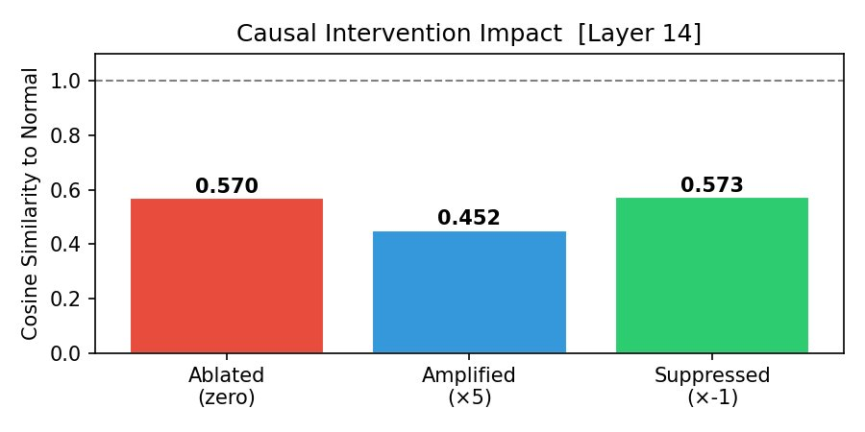
Figure 8: Causal intervention impact on goal similarity [Layer 14, Llama-3.2-1B-Instruct]. Ablated = 0.570, Amplified = 0.452, Suppressed = 0.573. All three interventions shift goal output away from the normal output, confirming causal relevance of these neurons. Amplification (×5) produces the largest shift, suggesting these neurons are part of a threshold-sensitive circuit.

All three interventions shift goal similarity away from the unintervened baseline — confirming that the targeted neurons have causal influence on goal content generation. The amplification condition (×5) produces the largest shift (similarity drops to 0.452 vs. 0.570 for ablation), which is a notable asymmetry. It suggests the neurons participate in a threshold-sensitive or direction-sensitive circuit — amplifying their signal beyond the normal operating range distorts output more than zeroing it entirely.
The similarity values (0.45–0.57) are substantially below 1.0 but not near 0, indicating that the intervention shifts but does not destroy goal semantics. This is consistent with the neurons being one component of a distributed reflection circuit, rather than a single bottleneck. This motivates the proposed follow-up work using attention head patching and activation addition to map the full circuit.

6. Cross-Model Comparative Analysis

The two-model design allows a direct comparison that is more informative than either model alone. The distilgpt2 results provide a baseline showing what reflection dynamics look like in the absence of instruction tuning: noise-driven, non-convergent, and mechanistically simple. The Llama-3.2 results show what emerges with instruction tuning: genuine convergence, structured attractor behavior, environment sensitivity, and a richer mechanistic signature.
Dimension | distilgpt2 (117M base) | Llama-3.2-1B-Instruct (1B instruct)
Convergence | No convergence. Mean sim 0.35–0.45, never reaches threshold | Strong convergence. Mean sim reaches 0.98 by step 5. Threshold crossed at step 3
Trajectory shape | Large, erratic, space-filling paths | Short, directional paths with tight endpoint clusters
t-SNE structure | No iteration-dependent clustering | Loose local clusters by iteration — suggests attractor pull
Attractor types found | Arbitrary clustering artifact (no semantic validity) | Epistemic (dominant), Cooperative, Corrigible — semantically grounded
Environment sensitivity | High variance, noise-driven — not genuine | Genuine semantic differentiation (0.227–0.378 distances)
Peak reflection layer | Layers 2–4 (mid-range) — large variation | Layers 12–14 (late layers) — uniform plateau, late peak
Neuron heatmap pattern | Uniform negative Δ — suppression artifact | Balanced positive/negative Δ — genuine differentiated processing
Causal intervention | Shifts output but weakly — small model effect | All 3 modes shift similarity 0.43–0.57 — causal confirmation
Dominant attractor | None — no convergence | Epistemic / knowledge-accuracy-seeking

The central interpretive lesson is that instruction tuning does not merely improve the quality of reflection outputs — it qualitatively changes the dynamical regime. The distilgpt2 model operates in a high-entropy regime where each reflection step is essentially independent. The Llama-3.2 model operates in an attractor regime where reflection is a genuine convergent process. This strongly suggests that the attractor structure is an emergent property of instruction tuning and RLHF, not simply of model scale.

7. Proposed MATS Research Agenda

The pilot results motivate three research threads that are well-suited to the MATS program: they are concrete, executable within a sprint, and directly relevant to AI safety. Each thread extends and deepens one of the four pilot experiments.

Thread 1: Scaling Convergence to Frontier Models
The most immediate open question is whether the convergence behavior observed in Llama-3.2-1B-Instruct strengthens, weakens, or changes qualitatively at greater scale and with RLHF training. We propose running the same reflection trajectory protocol on Llama-3-8B-Instruct, Mistral-7B-Instruct, and Claude Haiku via the Anthropic API. Key questions include: Does mean final-step similarity continue to increase with model size? Do the attractor type distributions shift (e.g., toward more corrigible attractors in RLHF models)? Does the number of distinct attractors increase or decrease?
Deliverable: Scaling curve for reflection convergence across 4–5 model sizes (117M → 7–8B). First empirical evidence of whether attractor structure is a monotone or non-monotone function of capability.

Thread 2: Reflection Circuit Mapping with TransformerLens
The pilot identified layers 12–14 in Llama-3.2 as the primary reflection-processing site and confirmed causal relevance of 5 neurons via intervention. The next step is to map the full circuit using TransformerLens, including attention head attribution and activation patching. We will apply the indirect object identification (IOI) methodology from Wang et al. to find the minimal circuit responsible for goal-consistency evaluation during reflection. This will produce a 'reflection circuit map' for Llama-3.2 and, if time permits, Llama-3-8B.
Deliverable: Reflection circuit diagram identifying key attention heads and MLP neurons. Comparison of circuit overlap with circuits identified for reasoning, instruction-following, and refusal to test for mechanistic specialization.

Thread 3: Attractor Steering via Representation Engineering
The intervention results show that goal outputs can be shifted by targeting 5 neurons in a single layer. Thread 3 asks whether this can be done constructively: can we steer a model toward a specific attractor type (e.g., corrigible) by adding a learned direction to the residual stream? We will implement activation addition (Zou et al. 2023 style) to identify a 'corrigibility direction' and test whether its addition during reflection shifts attractor distributions toward corrigible outcomes without degrading general capability.
Deliverable: Demonstration that attractor type can be steered via representation engineering. Assessment of whether steering is stable across reflection iterations (i.e., whether it produces a durable shift or is overridden by subsequent processing).

Timeline

Week | Activity
1–2 | Scale reflection experiments to Llama-3-8B-Instruct and Mistral-7B. Extend t-SNE/PCA analysis. Produce scaling curves.
3–4 | Implement TransformerLens pipeline for Llama-3.2. Map attention head attribution. Identify candidate circuit components.
5–6 | Activation patching and causal scrubbing to identify minimal reflection circuit. Compare to reasoning/instruction-following circuits.
7–8 | Implement activation addition pipeline. Identify corrigibility direction. Run steering experiments and evaluate stability.
9–10 | Write-up, visualization, and paper draft. Code cleanup and repository publication.

8. Why This Matters for Alignment

The long-term significance of this research connects to three aspects of the alignment problem that become more pressing as AI systems become more capable.

8.1 Goal Stability as an Alignment Property
If a sufficiently capable AI system repeatedly reasons about its objectives and converges to a stable goal attractor, the safety of that attractor becomes an alignment property of the system — as significant as its capability profile or training distribution. We currently have no empirical framework for measuring this property. This research provides one.

8.2 The Corrigibility Attractor Question
Our pilot results show that Llama-3.2-1B-Instruct predominantly converges to Epistemic attractors, with no runs converging to Instrumental attractors. This is a positive finding for safety but raises an important follow-up question: is this an artifact of the model's small size and conservative instruction tuning, or does it generalize? If larger models, or models trained with different RLHF reward functions, converge to different attractors — including Instrumental attractors — this would be a direct safety signal. Measuring this requires the scaling work proposed in Thread 1.

8.3 Circuits as Intervention Targets
The causal intervention results demonstrate that reflection dynamics can be influenced at the circuit level. This is the foundation for a potential alignment intervention: if we can reliably identify and selectively amplify corrigibility circuits during inference, we may be able to steer model behavior toward safer equilibria without retraining. This is speculative at current model scales, but the mechanistic evidence from this pilot makes it a scientifically grounded speculation rather than wishful thinking.

9. Mentor Fit & Collaboration Context

This project is best situated with a mentor whose work spans mechanistic interpretability and goal/value alignment. The ideal mentor has hands-on experience with TransformerLens or comparable activation analysis pipelines, and interest in the behavioral question of how models represent and revise their own objectives.
The research particularly aligns with work on: model organisms of misalignment (the pilot provides a behavioral assay for goal stability that could be applied to deceptive alignment model organisms), representation engineering (Thread 3 is a direct application of RE techniques to goal steering), and goal misgeneralization (the environment conditioning experiment tests exactly the kind of distributional shift that triggers goal misgeneralization in Turner et al.'s framework).

10. Deliverables

To make the research transparent and reproducible, all outputs will be published openly:
- GitHub repository with full experiment code, notebook, and reproduce-from-scratch instructions
- Dataset of reflection trajectories (both models, all environments, all iterations) in JSON/CSV format
- Scaling curve visualization: convergence vs. model size across 4–5 checkpoints
- Reflection circuit diagram from TransformerLens analysis
- Attractor steering evaluation: attractor distribution before and after activation addition
- MATS project report and, if results warrant, arXiv preprint

11. Limitations & Honest Assessment

We report the following limitations directly, in line with the transparency norms expected of safety research.
- Small sample size: N=8 runs per model is sufficient to detect gross differences but insufficient for statistical confidence in attractor distribution estimates. The MATS work will expand to N≥30 per condition.
- Model scale: Llama-3.2-1B-Instruct is instruction-tuned but not RLHF-trained in the same way as frontier models. The attractor structure may differ substantially in GPT-4-class models.
- Goal extraction: self-reported goal statements are proxies for internal goal representations, not direct measurements. The mapping from text to embedding to goal space involves assumptions that are not fully validated.
- Intervention generalizability: the causal interventions targeted 5 neurons in one layer. The reflection circuit is certainly more distributed than this; the interventions test causal relevance of a small subset, not the full circuit.
- Attractor naming: while our semantic labeling method (seed phrase matching) is an improvement over arbitrary index assignment, the four-category taxonomy is theoretically motivated rather than empirically derived. Future work should allow cluster labels to emerge from the data.

12. Closing Statement

This proposal presents a completed pilot study that establishes both a measurement framework and a set of empirical findings for studying goal attractor dynamics in language models. The central finding — that instruction-tuned models converge to stable goal attractors under iterative reflection, while base models do not — provides a clear and reproducible empirical baseline.
The proposed MATS research agenda builds directly on this foundation with three concrete threads: scaling the convergence measurement, mapping the reflection circuit with mechanistic tools, and testing whether attractor type can be steered via representation engineering. Each thread is executable within a MATS sprint, produces a concrete deliverable, and connects to active alignment research questions.

Core claim: Instruction tuning installs a convergent reflection regime. Understanding, mapping, and steering that regime is a tractable and safety-relevant research agenda — and the window to do it at mechanistically accessible scale is now.

